BOISE STATE UNIVERSITY
NATIVE AMERICAN/MINORITY SCHOLARSHIPS

S107 - Bill R. McCracken Scholarship Fund
The Bill R. McCracken Scholarship Fund was established in 2004 by Bill R. McCracken, a graduate of Boise Junior College in 1969 and an Alumni Associate since 1982, for the purpose of establishing a scholarship to support a student in the College of Business and Economics with preference given to Native Americans and Minority students.
Criteria:
- Registered at Boise State University full-time (12 credits or more)
- Required Major: any major in the College of Business and Economics
- Minimum cumulative grade point average: 3.0
- Required: Financial need as defined by the Boise State University Financial Aid Office
- Preferred: Native American and Minority Students
BR144 - Flandro Family Scholarship
The donor, Debbie Flandro, believes in supporting the advancement of Boise State University and Native Americans including the Kalispel Tribe of which she is a proud member. At Boise State she has served on the COBE Advisory Council since 2004, including the role of president beginning in 2016. Debbie also serves as Chairman of the Gaming Board for Northern Quest Casino, owned and operated by the Kalispel Tribe of Indians in Spokane, Washington. Debbie became the third tribal member to graduate from College when she earned her accounting degree and later added an MBA, both from Boise State. Debbie went on to a successful career at Hewlett-Packard that spanned 27 years.
Criteria:
- Registered at Boise State University full-time (12 credits or more undergraduate; 9 credits graduate)
- Required Major: any major in the College of Business and Economics
- Minimum cumulative grade point average: 3.0 for undergraduate; 3.5 for graduate
- Required: Financial need as defined by the Boise State University Financial Aid Office
- Required: Member of a federally recognized Native American tribe
AS071 - Annice Hattoon Edmundson Scholarship
The Annice Hattoon Edmundson Scholarship was established in 1991, by Eldon and Phyllis Edmundson. The scholarship was established to help students at Boise State University who are working towards t heir Music degree. The Edmondson’s know that juniors and seniors need to be encouraged financially in order for them to reach their potential; therefore they developed this scholarship with them in mind.
Criteria:
- Registered at Boise State University full-time (12 credits or more)
- Required major: Music Education
- Minimum cumulative grade point average: 3.0
- Junior or Senior status
- Required: Financial need as defined by the Boise State University Financial Aid Office
- Preferred: Minority Students
ER061 - Roy and Beverly Grice Education Scholarship
The Roy and Beverly Grice Education Scholarship was established in 2010 by Roy and Beverly Grice. Roy and Beverly Grice both attended Boise State University. Roy received a BA in 1972 as a History major and Beverly received a BA in 1972 as an Elementary Education major. In 1982 Beverly then received an MA in Literacy/Reading. Beverly taught in elementary education for many years until her retirement. It is for this reason that the Grice’s decided to establish a scholarship for Education majors at Boise State. Roy and Beverly’s goal is for the selected students to have little or no educational financial debt upon graduation.
Criteria:
- Registered at Boise State University full-time (12 credits or more undergraduate; 9 credits graduate)
- Required Major: Education
- Minimum cumulative grade point average: 3.0
- Required: Financial need as defined by the Boise State University Financial Aid Office
- Preferred: Minority Students
ES085 – John Jensen Minority/Migrant Education Scholarship
The John Jensen Minority/Migrant Education Scholarship was established in 1999 by the late John Jensen, a Boise State education professor. Jensen recognized the great need to increase the number of talented minority and migrant or seasonal farm worker youth in the teaching profession. He wanted to encourage these youth and their dependents to pursue careers in teacher education, therefore becoming mentors for other minority and migrant youth. Jensen was granted emeritus status upon his retirement in 2000, after teaching at Boise State for more than 30 years.
Criteria:
- Registered at Boise State University full-time (12 credits or more)
- Required Major: Education
- Minimum cumulative grade point average: 2.5
- Sophomore, Junior, Senior status
- Required: Student must be from minority group or have a migrant or seasonal worker background.
- Supplemental Requirement: Student must submit an additional essay on why he/she wants to be a teacher and what their contribution will be.

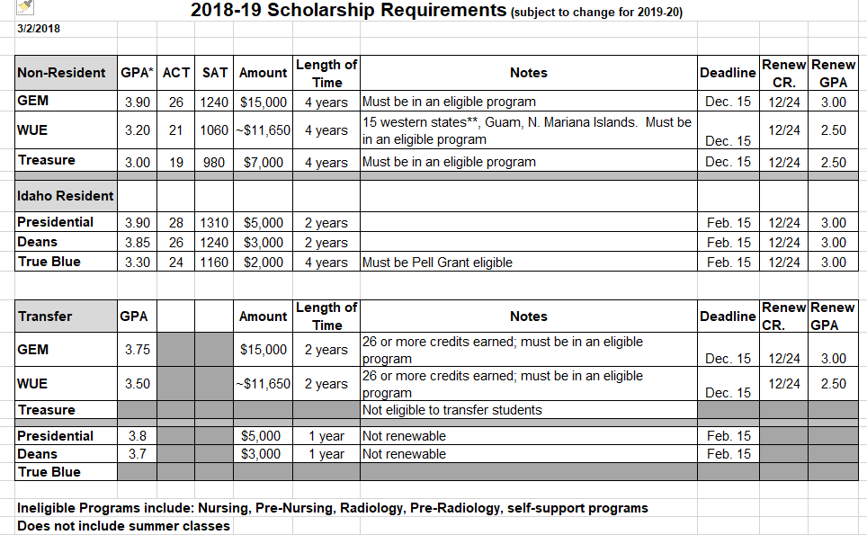

IDAHO STATE UNIVERSITY
SCHOLARSHIPS AVAILABLE TO NATIVE AMERICAN STUDENTS

- American Indian Resource Fund
Emergency funds for Native American students. Used to provide support for Native American students who are in extreme situations requiring financial help. Students must be enrolled full-time, and have a minimum 2.0 GPA. Student must be an enrolled member of a federally recognized tribe. Log into BOSS to apply. www.isu.edu/scholarships

- Anne Staton Voilleque-Lousie Smith Nelson Scholarships Endowment
The *Anne Staton Voilleque-Lousie Smith Nelson Full Tuition Scholarship* is awarded to Undergraduate students of any major and class level. The students must be registered full-time with a minimum 2.0 cumulative GPA. Financial need is required (FAFSA must be submitted). MUST be Native American from a reservation in Idaho. Renewable dependent on class level; available funds; progress towards intended degree. Log into BOSS to apply. www.isu.edu/scholarships

- ATCO Scholarship Fund for Native Americans
The *ATCO Scholarship* is for Native American students enrolled full-time in any program of study at ISU. Students must be in their second semester (for the College of Technology) or second year (non-College of Technology) of their respective program. Must have a minimum 2.50 cumulative GPA. Must be a resident of Southeast Idaho and a U.S. citizen. Preference will be given to students who demonstrate financial need (FAFSA must be submitted). Part of Combined Minority Awarding Committee. Log into BOSS to apply. www.isu.edu/scholarships

- Ben Davis Memorial Scholarship
The *Ben Davis Memorial Scholarship* is for students in any major or class level as an Undergraduate or College of Technology student. Students must have a minimum 2.00 cumulative GPA. Financial need may be considered. Must be enrolled members of the Shoshone-Bannock Tribe. Must be a U.S. Citizen. Preference is given to Academic students. Log into BOSS to apply. www.isu.edu/scholarships

- Donald L & Helen Doering Nielson Fellowship Scholarship
The Donald L & Helen Doering Nielson Fellowship Scholarship is one of many scholarships that are part of the Combined College of Education Scholarship Application. Preference is to a full-time (graduate) Student who is Native American and from Fort Hall Idaho. 2nd Preference to a full-time Junior, Senior Native American (undergraduate) from Fort Hall. 3rd Preference to a full-time Junior, Senior (undergraduate) with financial need. Recipient must indicate strong intentions to work with a Native American community upon graduating. If no eligible candidates from above - student may be considered as follows: First Priority - Native American undergraduate students. Second Priority: COE student in need. Dean of Education will provide ongoing duties to fellowship recipient relating to the ongoing support, development, and recruitment of minority students in the College of Education. _*Awards renewable for a max of 3 years. Log into BOSS to apply. www.isu.edu/scholarships

- Dr. Carol L Bagley Scholarship
The *Dr. Carol L Bagley Scholarship* is one of many scholarships that are a part of the Non-Traditional Scholarship program. Students must be majoring in the College of Arts and Letters (preferably studying English, American Studies or Native American Literature), but can be any class level. Must be a full-time student with a minimum 2.00 cumulative. Financial need is required or must have compelling reasons for need of the scholarship. This award is provided to deserving older students. A student must be the age of 27 or older to receive this award. Must be a U.S. Citizen. Log into BOSS to apply. www.isu.edu/scholarships

- Frank J & Carol J Thomas Scholarship
The *Frank J & Carol J Thomas Scholarship* is one of many scholarships that are part of the Minority Scholarship program. Students can be in any class level or major. Students must have a minimum 2.00 cumulative GPA. First preference is given to Native American students majoring in Business, particularly those from the Fort Hall Indian Reservation. Second preference is given to a deserving student majoring in Business who demonstrates financial need. Log into BOSS to apply. www.isu.edu/scholarships

- MarDeane Carver Jordan Merit Scholarship
The *MarDeane Carver Jordan Merit Scholar Scholarship* is awarded to a Native American student (must show proof). Can be any major and class level. Academic Success, demonstration of exceptional leadership in his/her community, academic program, or profession required. Letter of nomination (reference) required. Must be a full-time student and have a minimum GPA of 2.00. Log into BOSS to apply. www.isu.edu/scholarships

- Marguerite Henderson Scholarship
The *Marguerite Henderson Memorial Scholarship* is one of many scholarships that are part of the Minority Scholarship program. Students can be in any major or any class level. Students must have a minimum 2.00 cumulative GPA. Preference is given to a resident of Pocatello who is African American or to a member of the Shoshone-Bannock Tribe. Must be an Idaho Resident and a U.S. Citizen. Log into BOSS to apply. www.isu.edu/scholarships

Marie L Hopkins Memorial Scholarship
The *Marie L. Hopkins Memorial Scholarship* is one of many scholarships that are part of the Minority Scholarship program. Students can be in any major or any class level. Students must have a minimum 2.00 cumulative GPA. Financial need may be considered. First preference is given to students who are relatives of Marie L. Hopkins. Second preference is given to Shoshone or Bannock tribe students. Must be a U.S. Citizen. Log into BOSS to apply. www.isu.edu/scholarships

- Thomas & Lucille Townsend Scholarship
The *Thomas & Lucille Townsend Scholarship* is awarded to a student with a minimum 3.0 GPA. Student must demonstrate financial need. Preference will be given to students who are Native American. If no suitable candidates are available, preference may be given to other American minorities. Part of Combined Minority Awarding Committee. Log into BOSS to apply. www.isu.edu/scholarships.

Other Recruitment and various scholarship programs:

New Incoming Idaho Residents (Freshman): Scholarship Awarding Index for Idaho Residents; Graduates of an Idaho High School; and first time students. Must be admitted by 2/15 for Fall Entry and 11/1 for Spring Entry:

See Idaho Resident Awarding Grid at: https://www.isu.edu/media/libraries/scholarships/AwdIndx_IdRes.pdf

New Incoming Non-Idaho Residents: Scholarship Awarding for Non-Idaho Residents. Must be admitted by 2/15 for Fall Entry and 11/1 for Spring Entry:
See Non-Resident Tuition Waivers and Western Undergraduate Exchange Awarding at:
https://www.isu.edu/scholarships/non-resident-tuition-waivers-/

Idaho Resident and Domestic Non-Resident Transfer Scholarship Awarding Index: for undergraduate students earning their first undergraduate degree with 24 or greater transfer credits and no more than 100 post high school non-AP transfer credits at the time of the scholarship deadline. Must be admitted by 2/15 for Fall Entry and 11/1 for Spring Entry.

See Transfer Awarding Index at: https://www.isu.edu/media/libraries/scholarships/TRANSFER-AWARDING-INDEX1516_FINAL.pdf

ISU Summer Bridge Program:
Summer Bridge Program link is: http://www2.isu.edu/success/bengalbridge/
Bengal Bridge Application deadline: before April 15
Application and further information is in link above.

American Indian Tuition Fee Program:
Members of Idaho’s five federally-recognized American Indian tribes can now attend ISU at a reduced tuition rate of $60 per credit hour beginning fall 2018. The program was approved by the Idaho State Board of Education in June, and applies to members of the Shoshone-Bannock, Nez Perce, Shoshone-Paiute, Kootenai and Coeur d’Alene Tribes. To be eligible students must be degree-seeking, eligible to enroll in ISU courses and apply for federal student financial aid through the FAFSA program. The discounted rate is for tuition only, other institutional, program and/or class fees still apply. For more information about the program, see Frequently Asked Questions or contact ISU Native American Student Services

UNIVERSITY OF IDAHO
Pre-College Programs:
Helping Orient Indian Students and Teachers to STEM (HOIST) https://www.uidaho.edu/diversity/dhr/native-american-student-center/academics/hoist
Goals:
Provide STEM education to Native American students
Recruit and retain Native American undergraduate students in STEM majors
Provide education to current and future teachers to better instruct Native American students in STEM fields
- No cost to attend
- Deadline for application is May 1st
- Summer program component is June 10th-July 13th
- Target is Idaho Tribes and UI MOU Tribes
- Includes Bridge program for high school graduates who have been accepted to UI

For academic year 17-18 the UI Native American Student Center awarded 40 UI native students via our Diversity Scholarship Committee. Diversity scholars are required to participate in the INSTEP retention program and be full time on the Moscow campus. Students also need to maintain a 2.3 GPA.

LEWIS-CLARK STATE COLLEGE
Funding your Education
Native American/Minority Student Scholarships
- Avista Scholars Diversity Scholarship
- The Leona A. Craw Memorial Scholarship
- Dean and Colleen Mahoney Scholarship
- The H. William and Barbara Belknap Scholarship
- Plateau Native American Trust Scholarship
- Riddle Family Scholarship
- The Andrew L. Smith Memorial Scholarship
- Isaac "Ike" Wilson Memorial Scholarship
- Native American Alumni Chapter Scholarship
Learn more information about these scholarships at: http://www.lcsc.edu/financialaid/scholarships-and-waivers/minority/.
Nez Perce Technical Waivers
Enrolled members of the Nez Perce Tribe who are taking classes in Vocational-Technical Certificate and AAS programs at LCSC are eligible for technical fee waivers. Students must provide proof of tribal enrollment to the Controller's Office. For more information contact the Director of Native American, Minority & Veterans' Services at (208) 792-2812 or email Bob Sobotta at bsobotta@lcsc.edu.
Residency for Tribal Members
A student enrolling at Lewis-Clark State College may prove classification as an Idaho resident for tuition purposes by meeting the criteria of: Member of the following Idaho Native American Indian Tribes. Members of the following Idaho Native American Indian Tribes “whose traditional and customary tribal boundaries included portions of the state of Idaho, or whose Indian tribe was granted reserved lands within the state of Idaho”:
- Coeur d’Alene;
- Shoshone-Paiute;
- Nez Perce;
- Shoshone-Bannock;
- Kootenai; or
- Eastern Shoshone
- Lewis-Clark State College also recognizes the following American Indian tribes' customary boundaries: Spokane, Kalispel, Colville Confederated Tribes, Confederated Salish-Kootenai Tribes, Confederated Tribes of the Umatilla Indian Reservation and Yakama Tribes.
Pre-college programs
LCSC offers dual credit opportunities. Idaho students pay $65/credit. Payment deadlines are the end of October for Fall semester and end of March for Spring semester. Our Natural Science Department has in the past offered a Math Camp for incoming students.
94 scholarships awarded to American Indian students this year.
Scholarship Coordinator is Courtney Robinson.
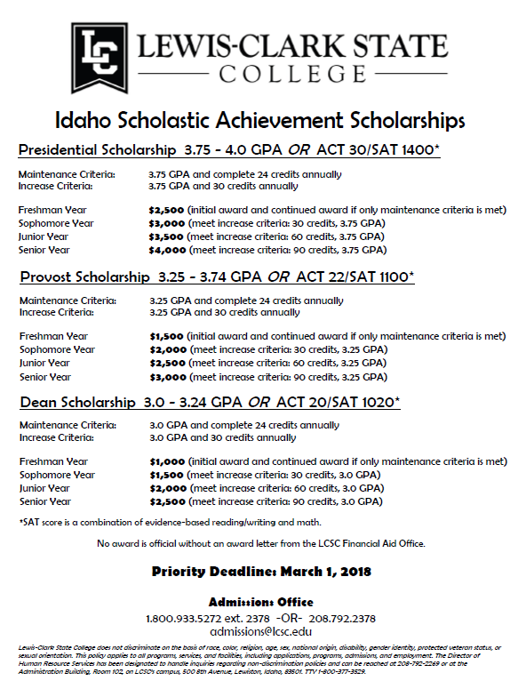
Attached our flyer on our merit based scholarships for the GPA scholarship grid information.

COLLEGE OF SOUTHERN IDAHO
New scholarship available
The College of Southern Idaho
Hedrick Family Memorial Scholarship
This scholarship has been established in honor and recognition of Clarence F. Hedrick, Beth S. Hedrick and Nanette Hedrick Songer’s contribution to, support of and commitment to higher education for all financially challenged students who are dedicated to a career in agriculture, education on Indian Reservations/rural western states and/or public service.
Scholarships can be renewed if the recipient continues to meet the requirements; however, recipients must reapply to be considered for renewal. The amount received will depend on the annual amount available. The minimum annual award shall be $500. The donors will be selecting the scholarship recipients.
Requirements:
- Students must be focusing their education/future career in one of these areas:
  - Agriculture in the West
  - Teaching on Native American Reservations, in rural school districts and/or in small rural western communities
  - Improving the lives of rural Americans in western states through public service.

- Applicants do not need to be currently enrolled, but must apply for admission to CSI as a full-time student.
- All applications must be accompanied with an official transcript or official in-progress transcript with the latest cumulative grade point average on the transcript.
- Selection will be based on academic promise, initiative, and financial need.
The completed application on should be mailed to:

College of Southern Idaho
Scholarship Coordinator
P.O Box. 1238
Twin Falls, ID 83303-1238

Completed applications must be received not later than 5:00 p.m., August 1st, 2018.

Hedrick Family Memorial Scholarship Application

Name
 | (Last, First)
CSI Student ID # |  |  |  |  |  | Major
Mailing Address
 |  |  | (City) |  | (State) |  |  |  |  | (Zip)
Phone |  |  |  |  | Email
High School |  |  |  |  | Graduation Date

Provide a statement of your educational/career aims and how they will meet the criteria of this scholarship. Include (if applicable) work experience, volunteer and community service, service clubs participation, financial need, career goals and any other information you feel would help us make our decision.
Awarding rubric.
Our cost for 18-19 is $140/credit.
Presidential Freshman Award
Incoming freshmen who have not completed 26 credits by fall $250 or by spring $250. They need to have a 3.0 GPA from High School and be enrolled full-time.
New Hope
Incoming freshmen who have not completed 26 credits by fall $375-750 or by spring $375-750. Must be first generation student. Must be at least half-time and award is prorated.
Merit Awards
Must be at least half-time. Pro-rated by credits for HT, Three-Quarter time, FT. Annual awards at full-time rate below:
3.9-4.0 $3000
3.8-3.89 $2000
3.7-3.79 $1600
3.6-3.69 $1400
3.5-3.59 $1200
3.4-3.49 $1000
3.3-3.39 $800
3.0-3.29 $500

COLLEGE OF SOUTHERN IDAHO
Scholarships
- CSI General Scholarships
  - We have awarded ALL Eligible applicants for the last 3 years!!
  - 300 Funds (2.45M for 18-19) matched to applicants by Scholarship Office
  - Presidential Scholarships ($100K)
- Must be admitted to CSI before you can apply
- Complete the CSI General Scholarship Application through the Finances Drop Down in your MyCSI student account
- Priority Deadline – March 1, 2018, Final Application Deadline – September 1, 2018
- Official in-progress transcript should be on file by March 1 and official completed transcript submitted by June 30.
- Scholarships that require a separate application are posted on our website
- Department Scholarships – See website, by major
- Student Organization Awards (Student Senate, Pep Band, Program Board, Ambassadors and many other opportunities)
- Outside Scholarships – required donor information on website
- State Scholarships: www.boardofed.idaho.gov, CSI will match 18-19 Gear Up II Awards to $200,000.
- WUE or WNRT program: https://www.csi.edu/_files/pdf/financial-aid/western-undergraduate-exchange.pdf

More information on our scholarships: https://www.csi.edu/financial-aid/scholarships/default.aspx

Annual Awards (For those who apply by deadline):
Presidential Freshman Grant: Incoming Freshman who had a HS GPA of 3.0 or higher will receive a Presidential Freshman award of $500. It requires full-time enrollment.
New Hope Scholarship: Incoming first-year first generation students who had a minimum of 2.75 GPA in HS are awarded. $1,500 full-time, $1,150 (9-11 credits) and $650 for (6-11 credits).
Merit awards: GPA based. Pro-rated by credits. 6 credit minimum for awarding. Top award for full-time enrollment and 3.9 GPA or above is $3,000. A 6 credit 3.0 GPA student would receive $250.
Students could receive all three. In addition, most of our student organizations offer scholarships based on participation. Departments offer additional awards as well (Ag, Health Sciences, Education etc.)
Typical annual scholarship package for a full-time incoming student with a 3.5 GPA:
Presidential Freshman $500
New Hope Scholarship $1,500
Merit Award $1,200
In-state annual tuition costs: $3,120, Scholarships $3,200. Student would have those funds for books. Pell would be awarded in addition, if eligible.

Requested Contact Information:
CSI Scholarship Office: Sarah Danielson, Scholarship Coordinator, sdanielson@csi.edu, (208) 732-6226
CSI Office of Admissions: Rebecca Mark, Welcome Center Coordinator, rmark@csi.edu, (208) 732-6360
CSI Financial Aid Office: Maria Rodriguez, Office Specialist, csifinancialaid@csi.edu, (208) 732-6274
CSI Advising Center: advising@csi.edu, (208) 732-6250

Bridge to Success Program: https://quondam.csi.edu/bridgetosuccess/
Dual Credit Academy: https://www.csi.edu/dual-credit/general-education-academy.aspx
Admissions: https://www.csi.edu/admissions/default.aspx
SOAR (Mandatory Orientation and Registration): https://www.csi.edu/admissions/events/soar.aspx

